# **Exercise 4: Arrange-Act-Assert (AAA) Pattern, Test Fixtures, Setup and Teardown Methods in JUnit**

## 

## **Scenario**

You need to organize your tests using the Arrange-Act-Assert (AAA) pattern and use setup and teardown methods in JUnit.

### **Arrange-Act-Assert (AAA) Pattern**

I wrote tests following the AAA pattern: - Arrange: Prepare the objects and data. - Act: Execute the method under test. - Assert: Check the result is as expected.

### **Setup and Teardown**

I used @Before to run code before each test to set up the test environment, and @After to clean up after each test.

## **Calculator.java**

package com.example;  
  
public class Calculator {  
 public int add(int a, int b) {  
 return a + b;  
 }  
 public int subtract(int a, int b) {  
 return a - b;  
 }  
}

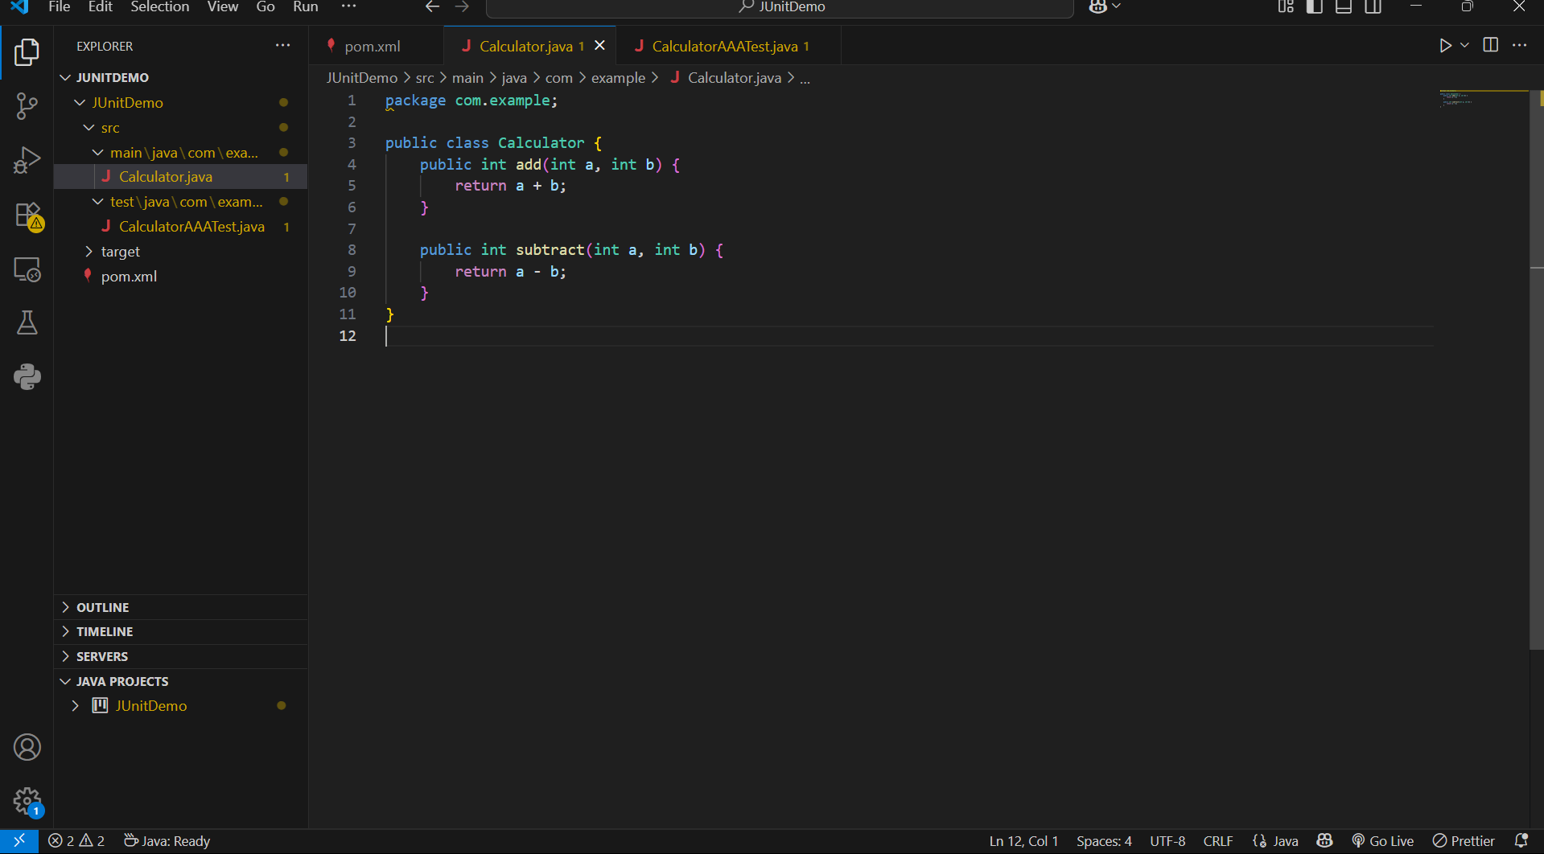

## **CalculatorAAATest.java**

package com.example;  
  
import static org.junit.Assert.*;  
import org.junit.Before;  
import org.junit.After;  
import org.junit.Test;  
  
public class CalculatorAAATest {  
  
 private Calculator calc;  
  
 @Before  
 public void setUp() {  
 calc = new Calculator();  
 System.out.println("Setup: New Calculator created");  
 }  
  
 @After  
 public void tearDown() {  
   
 calc = null;  
 System.out.println("Teardown: Calculator cleared");  
 }  
  
 @Test  
 public void testAdd() {  
   
 int result = calc.add(2, 3);  
  
 assertEquals(5, result);  
 }  
  
 @Test  
 public void testSubtract() {  
   
 int result = calc.subtract(10, 4);  
   
 assertEquals(6, result);  
 }  
}

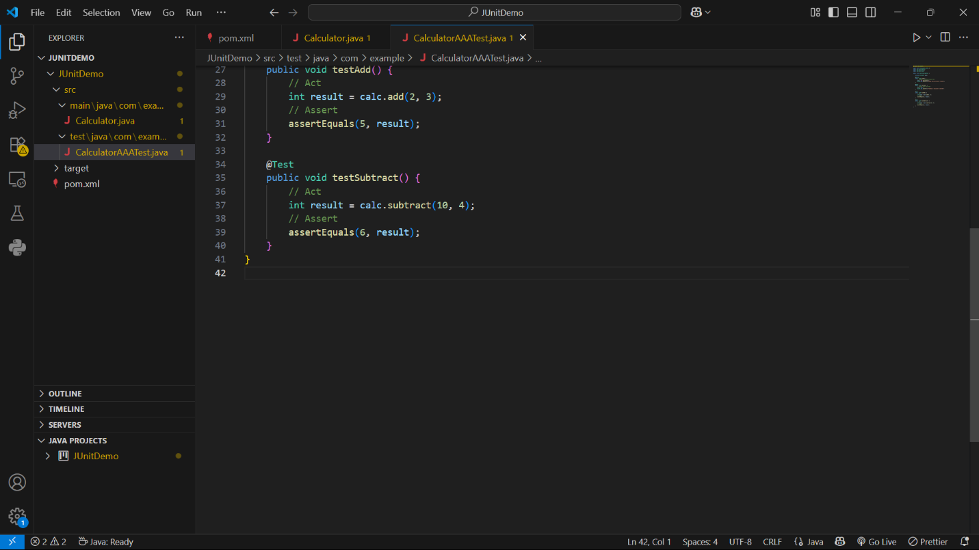

## **How to Run**

In the VS Code terminal:

mvn test

## **Sample Output**

-------------------------------------------------------  
 T E S T S  
-------------------------------------------------------  
Running com.example.CalculatorAAATest  
Setup: New Calculator created  
Teardown: Calculator cleared  
Setup: New Calculator created  
Teardown: Calculator cleared  
Tests run: 2, Failures: 0, Errors: 0, Skipped: 0  
  
Results :  
  
Tests run: 2, Failures: 0, Errors: 0, Skipped: 0  
  
[INFO] BUILD SUCCESS

